Rolle’s & MVT Theorem

# Verify the hypothesis of Rolle’s theorem for the following functions:

1. 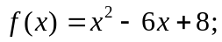 [2, 4]
2. 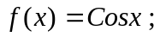 [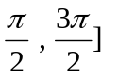
3. 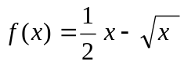 ; [0, 4]

# Verify the hypothesis of Mean value theorem for the following functions:

1. 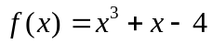 ; [-1, 2]
2. 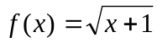 ; [0, 3]
3. 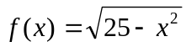 ; [ 0 , 5 ]

